**DIT4299 Software Development Project**

**Assignment**

**Group: 1**

**Group member: Ho Cheuk Ki Jacky (230091774)**

**Lo Sek Kong       (230154279)**

**Pang Wang Chun (230088026)**

**Tours App**

Tourism is a bridge that connects people who come from different regions, fostering mutual understanding and appreciation of various cultures. Hong Kong strategic approach of integrating culture with tourism, which let the tourism experience Hong Kong culture within their travel, aims to promote Hong Kong culture to the foreigner. It is the way that to enhance Hong Kong culture and tourism.

**Project Overview and Goals**

I cooperate in this project as a member with the team of two others member that we are all THEi students. We begin our project with a kick-off meeting with the client Tommy and discuss his project goals. We have asked about Tommy’s requirements and expectations.

The projects are going to be developed as promotional tools such as mobile applications, websites, and interactive games to enhance engagement. Most important aims are providing a tool for helping tourism when they travel to Hong Kong and also can promote Hong Kong tourism. Due to the digitalization requirements, Hong Kong tourism industry need to transform and innovation. According to the Culture, Sports and Tourism Bureau (CSTB), the government hopes that this tool can achieve the aims by innovation technology which enhancing the development of Hong Kong tourism.

Our design process consists of four main processes which are: **1. Research; 2. Planning; 3. Design; 4. Prototype.**

**Research**

Our research phase consists of the steps below: 1. Questionnaire; 2. Discussion

We have conducted a questionnaire for the foreigners to provide their point of view about the tools; some sample questions are as follow:

1. Which resource do you prefer when planning a trip? (To find out which tools are the target clients prefer most.)
2. Which channels do you use most to obtain travel information? (To get the reference from the tools they use most, which help in designing the user interface.)
3. Which method do you find most useful for providing travel information? (To get the reference from the tools they think most useful, which helps in deciding what information is needed in the tools.)
4. What factors influence your decision to use a particular method (website, Interactive game, or Mobile applications) to obtain travel information? (To get the factors that the client is most aware of.)

The result of the questionnaire showed that participants hope that the tools can be implemented in mobile applications. Most participants also thought that ease of use is the main factor in tools. Some of the participants suggested that they are hoping to gather the information on an integrated platform but not using different ways to do that.

After the questionnaire, we have invited some of the participants to join the discussion to know more about their thoughts. After the discussion, we summarized some of the features that they hope to include in the tools:

1. Providing different information such as Sightseeing information, Festival information and restaurant information.
2. Trip planner which helps travelers to plan their tour easily
3. Some guidance such as transportation suggestions or real time navigation.

One of the participants mentioned one pain point is that “there is too much information” which makes it very difficult to locate the information that he/she needs.

**Planning**

By finishing our research phase, we got a solid understanding of our user, business and project goals. The conclusion of goals are as follows:

User Goals

1. To provide sightseeing hotspots suggestions and restaurant nearby
2. To provide transportation suggestions

Business Goals

1. Promote Hong Kong tourism
2. Help tourism when they travel to Hong Kong

Project Goals

1. Keep the app simple and user friendly
2. Reach the user goals without compromising the business goals

**Persona**

Our persona is Alex Johnson and we consider our persona gender as man, Alex is Marketing Executive living in Sydney, Australia and like traveling. We outline the motivation, goals and frustrations of Alex as per below:

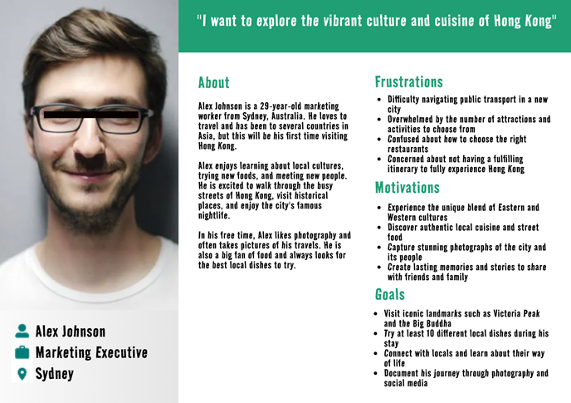

Due to the frustrations Alex has, we plan to mainly focus on the problem Alex has while he has to plan a trip. So, our app is designed to mainly show information, booking system, and transportation suggestions.

**User Journey map**

Our person (Alex Johnson) journey to search for traveling information in 5 phases, finding information of sightseeing, transportation, restaurants, the rating and comment of the restaurants, and counting budget during the planning of traveling, shows the impact that our app has on our user Alex Johnson. Due to the struggle to understand Alex’s pain point, we created the user journey map below to evaluate his actions, thoughts, and emotions. So, we can analyze possible opportunities.

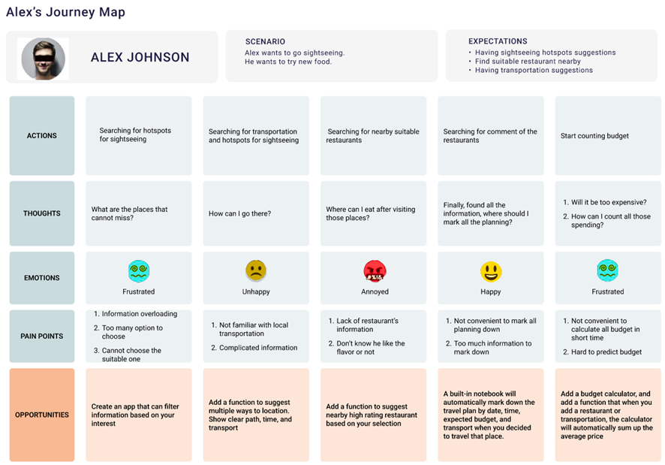Once the pain points were clear, we were able to formulate the problem and opportunities. So, we make the following sketch and storyboard to visualize our idea and planning.

**Storyboard**

After we figured out the priority of the main function, we started to draw the storyboard, storyboard is a visual tool to build empathy with the user, and further illustrate a user’s pain point, we identified areas which had great strengths in communicating the objective of the design purpose with arrows and analyzed them.

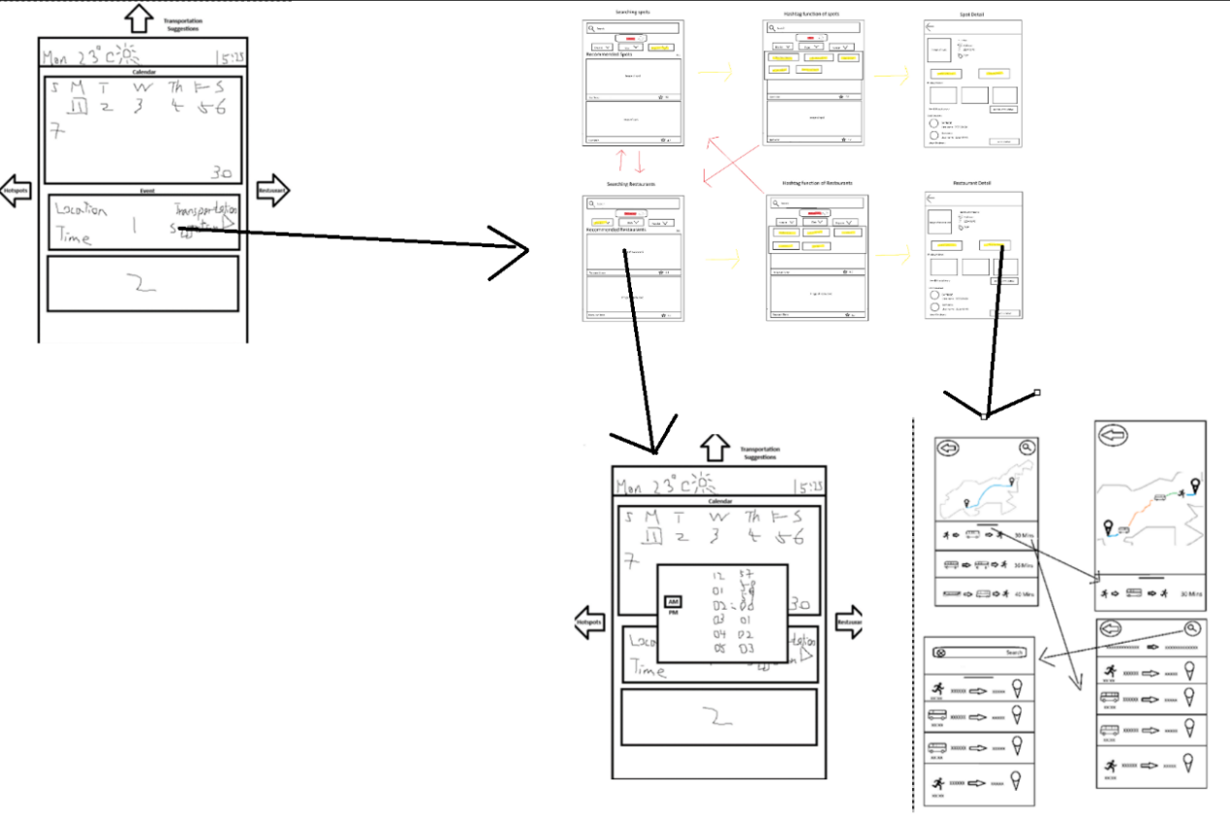

We had lots of ideas of the function besides the main function above, but after our discussion, we decided the sub-function will not be included in this phase of our application because too many functions at one application is too complex, that will lead to complex user interfaces and not user friendly.

**Sketch**

We narrow down our ideas to find out what are the essential functions that a travel app must have. Then we finalized the solution sketch with three components, which are trip planner, searching restaurants and tourism spots, and navigation.

**Trip planner**

We decided to use the trip planner as the home interface of our travel app. It shows a calendar in the upper part and a schedule in the lower part. We want to have a function which users can plan their trip.

**Searching restaurants and tourism spots**

We aim to help users to find out the restaurants and tourist spots that they are interested in and provide recommendations for the users who are frustrated on choosing restaurants and tourist spots. The solution has a search bar on the top which user can input content to search. We also provide hashtag function for the users who have no ideas on searching. They can choose restaurants/spots by selecting the hashtag from distinct, dish type of restaurant/type of spots and popular. The recommended restaurants/spots will be shown in the interface with images and restaurants/spots’ names.

**Navigation & Transportation Suggestions**

We aim to provide navigation with transportation suggestions to users. The upper part of the interface shows the map of Hong Kong, and the lower part of the interface shows the transportation suggestions for users.

**Prototype**

We chose Figma to prototype our app.

**Header**

We insert a grey header showing the current time and weather.

**Trip planner**

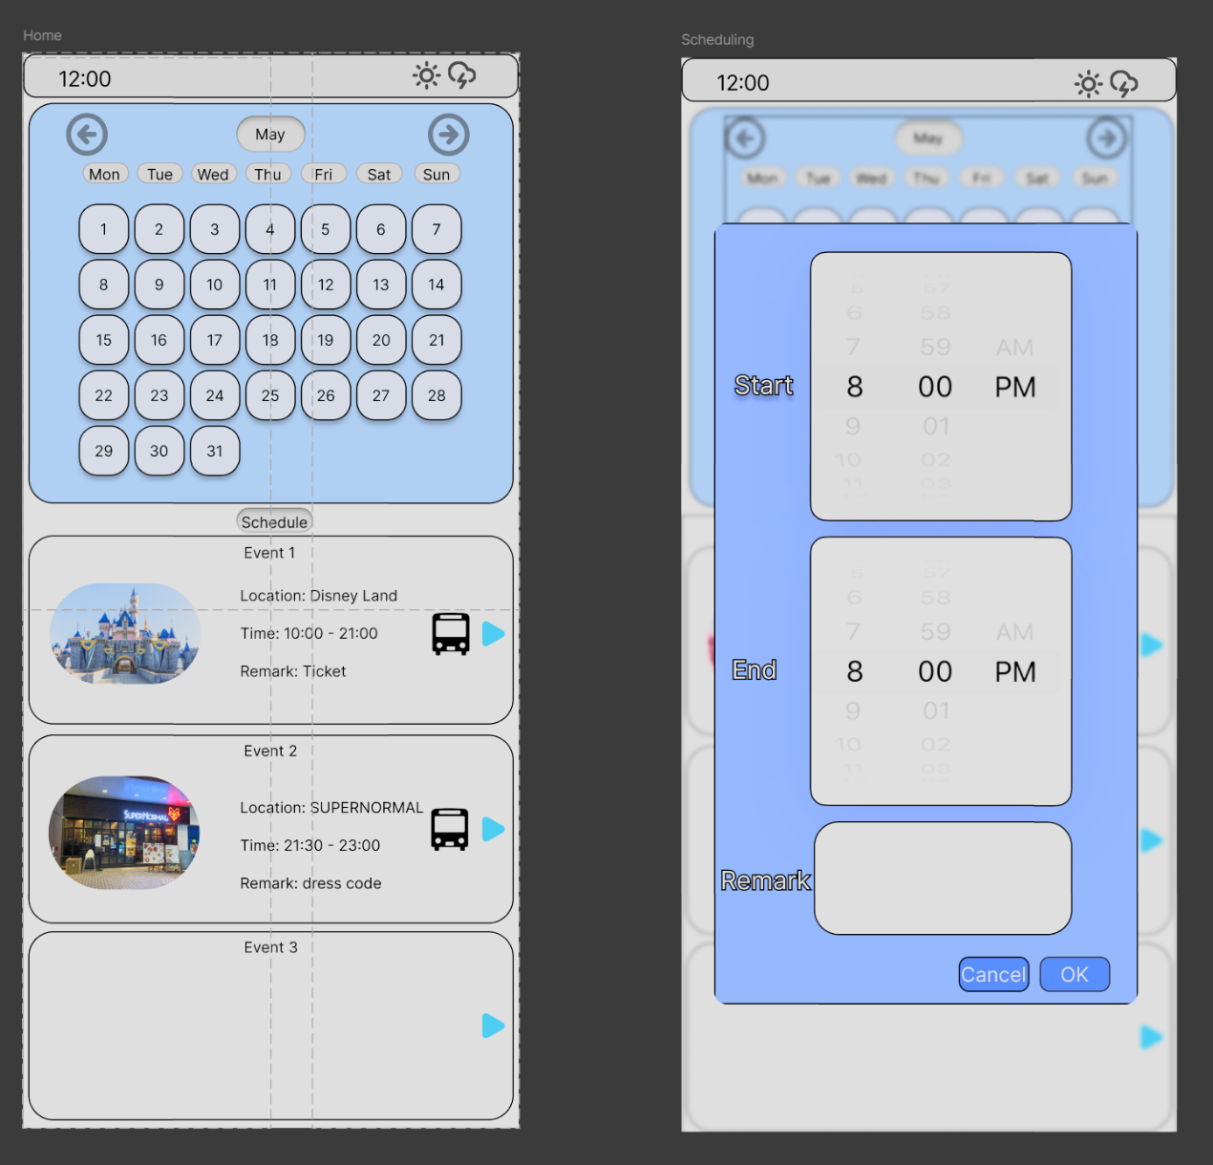

When users click the days of calendar, the schedule will show the information of the spots and restaurants including locations, time and remark that they have planned to go. If the schedule is empty, users can add events to the schedule with users’ favour timeslots.

**Searching restaurants and tourism spots**

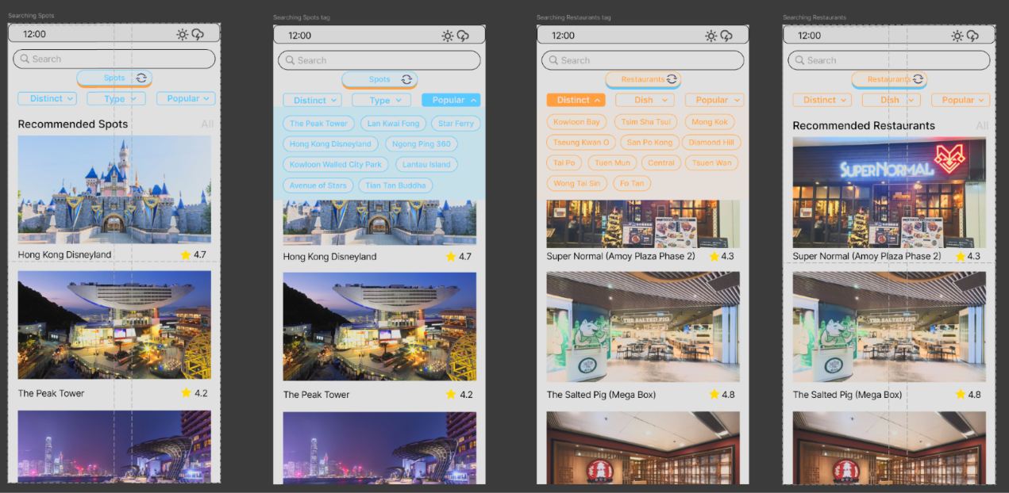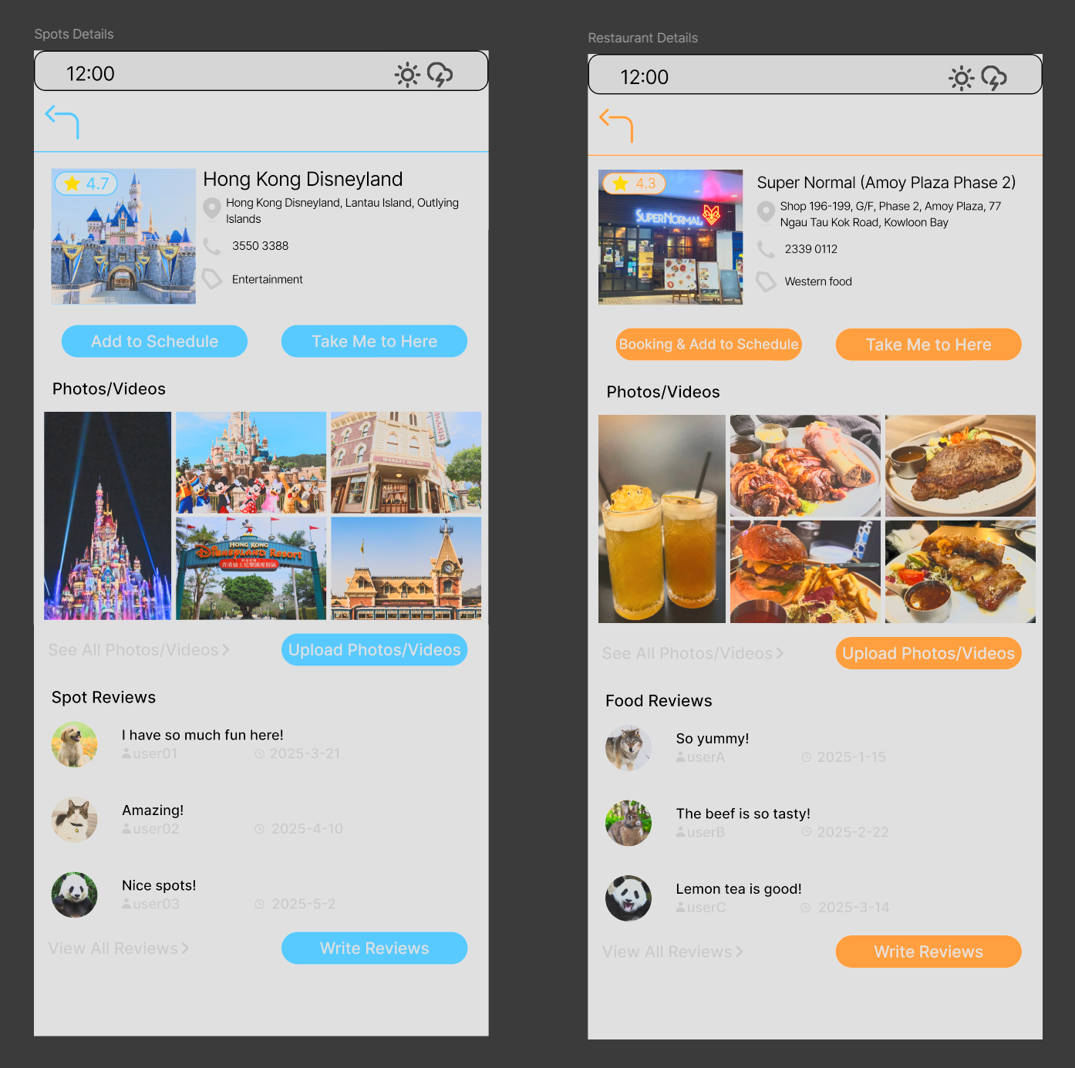

Once the users have searched or selected the hashtag, the recommended restaurants/spots will be listed out with images of restaurants/spots, restaurants/spots’ name and total rating given by other users. As the function of searching restaurants and searching spots is similar, considering our app should be user-friendly, we add a switch button under the search bar such that users can switch between searching restaurants and spots instantly by clicking the button to reduce redundancy. If users find out the restaurant/spot that they are interested in, they can click it for more details. The interface shows the information of selected restaurant/spot including location, phone number, photos/videos and reviews written by other users. Users can add selected restaurant/spot to the schedule, start navigation to restaurant/spot, upload photos/videos and write reviews after visiting spots or having meals in restaurants.

**Navigation & Transportation Suggestions**

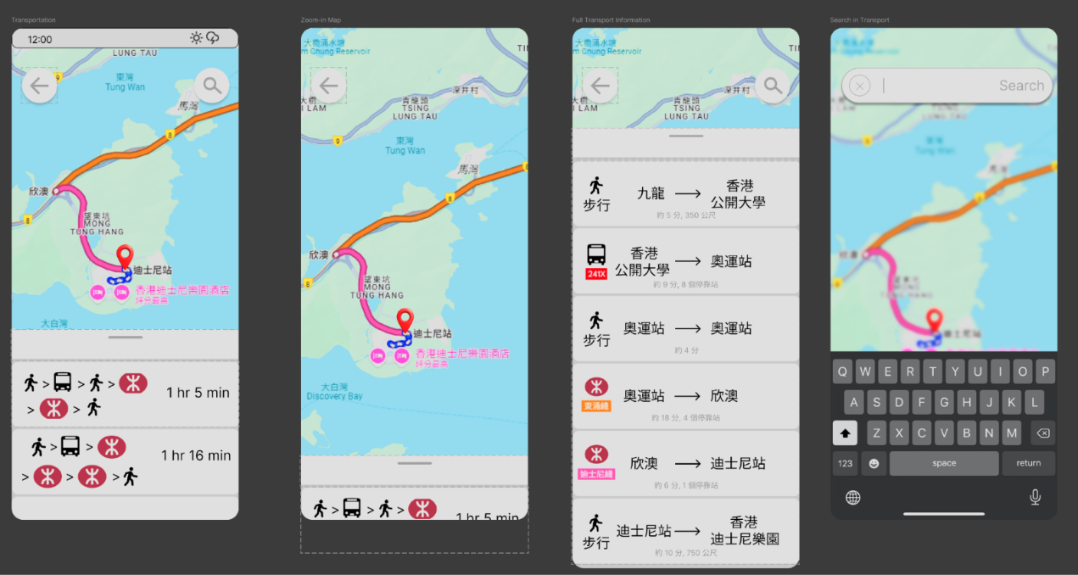

Users can set destinations by searching or clicking the button ‘Take me to here’ from the Restaurant/Spot Details. When the destination is located, navigation will start and provide transportation suggestions and show the estimated time of arrival.

**Visual Design**

**Logo**

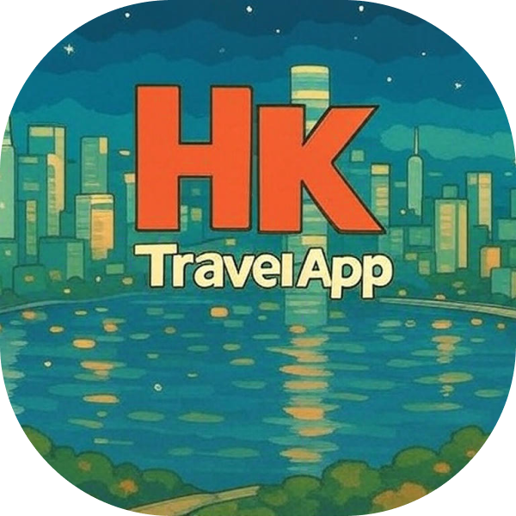

We use the word ‘HK TravelAPP’ with the night view of Victoria Harbour as our App logo. We choose Victoria Harbour because it is a famous symbol of Hong Kong. When users see our app logo then they can realize our app is for travelling in Hong Kong instantly. Also, we use colourful background to attract users to download our app.

**Color**

Our main colour themes are black, grey and white. We choose white background and black wording without using dazzling colours as we want our users to see clearly. Light blue calendars can make users concentrate more when looking at the calendar.

We use complementary colours for searching restaurants and tourism spots interfaces. Light blue represents spots and orange represents restaurants. Some users may feel tired of reading words, so we use complementary colours to help users know whether they are searching for spots or restaurants by two colours.